# Gran, Telescopio, Canarias, La Palma, Kanarische Inseln

Quarterly Problem

*- Science Edition -*

I spy with my little eye!

https://www.pixabay.com

*Watching the night sky full of stars, one naturally starts to wonder about the secrets the universe might bare.*

While people used to think that the starry sky is inhabited by gods and monsters, today we try to reconcile our observations with current scientific theories. Nevertheless, some questions remain unanswered. With ever larger and more efficient telescopes, astronomers are trying to gain new insights. But even with normal cameras, we can already discover interesting things in the night sky.

We photographed the night sky on the top of the mountain “Schauinsland” close to Freiburg, Germany. What do you see in the picture?

**→**

**Brainstorm-Box**

Do some research on how (digital) photography works. Do camera photos always show the truth, or can also cameras make mistakes?

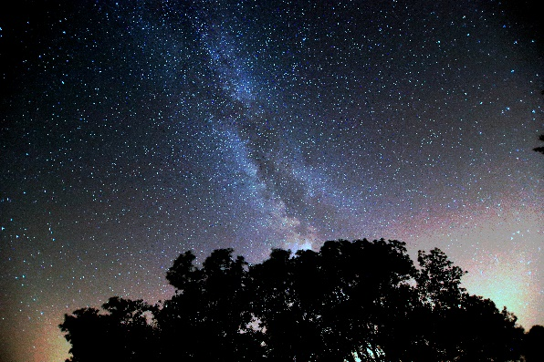

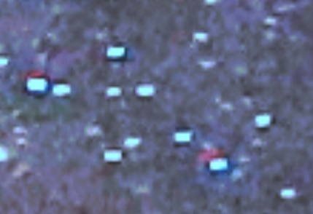

If you are looking very closely at the picture, you may think you see even more: some stars seem to have a red “shadow”. What could that be? But be careful, even cameras are not infallible!



© Oliver Straser /International Centre for STEM Education (ICSE), 2019

CC-BY-NC-SA 4.0 Licence granted

Picture Source: Oliver Straser